

MSc Data Science Project
7PAM2002
Department of Physics, Astronomy and Mathematics

Data Science FINAL PROJECT REPORT

Project Title:
Predicting Term Deposit Subscriptions in a Portuguese Bank using Direct Marketing Campaign Data

Student Name and SRN:
Aqsa Iqbal
24088421

Supervisor: Vid Irsic
Github: https://github.com/aqsawatto/DS_Project

DECLARATION STATEMENT
This report is submitted in partial fulfilment of the requirement for the degree of Master of Science in Data Science at the University of Hertfordshire.
I have read the detailed guidance to students on academic integrity, misconduct and plagiarism information at Assessment Offences and Academic Misconduct and understand the University process of dealing with suspected cases of academic misconduct and the possible penalties, which could include failing the project or course.
I certify that the work submitted is my own and that any material derived or quoted from published or unpublished work of other persons has been duly acknowledged. (Ref. UPR AS/C/6.1, section 7 and UPR AS/C/5, section 3.6)
I did not use human participants in my MSc Project.

I hereby give permission for the report to be made available on module websites provided the source is acknowledged.

Student Name printed: Aqsa Iqbal
Student Name signature
Student SRN number: 24088421

UNIVERSITY OF HERTFORDSHIRE
SCHOOL OF PHYSICS, ENGINEERING AND COMPUTER SCIENCE

Abstract
This paper explores how supervised machine learning models can predict customer subscription of bank term deposits based on the UCI Bank Marketing data. The study seeks to establish which model offers the best predictive performance in terms of evaluation metrics such as accuracy, precision, recall and F1-score. The systematic data science approach was used, including preprocessing of data, exploratory data analysis, feature transformation, and model development. Three classification algorithms were made and assessed including the Logistic Regression, Decision Tree and the Random Forest using stratified train-test splitting. The findings show that although the Logistic Regression had a high accuracy, it was poor at identifying true positive cases because of poor recall. Decision Tree model enhanced recall but with less precision and accuracy. Random Forest was the most successful of all models, with the highest accuracy, precision and F1-score, and a balanced trade-off between detecting positive cases and false predictions. The results indicate that ensemble learning techniques are better to work with complex and imbalanced data in financial marketing applications. The research underlines the significance of choosing the right evaluation measures and efficient models to enhance the process of making decisions using data and making the targeted marketing strategies in the banking industry more efficient.

Table of Contents
DECLARATION STATEMENT 2
Abstract 3
Table of Contents 4
1. Introduction 6
2. Literature Review 7
2.2 Review of Relevant Studies 7
2.2.1 Comparison of Comprehensive Classifier through CRISP-DM (Chian et al., 2024) 7
2.2.2 Bayesian Predictive Modeling Financial Uncertainty (Tanvir et al., 2024) 8
2.2.3 Solutions to the Class Imbalance Problem (Verma, 2019) 8
2.2.4 Machine Learning in Indian Banking (Keerthana et al., 2024) 9
2.2.5 Foundational CRISP-DM and Sensitivity Analysis (Moro et al., 2011) 9
2.3 Comparison of the Studies 9
2.4 Research Gap and Major Challenges 10
3. Ethical Issues 10
4. Methodology 11
4.1 Dataset Description 12
4.2 Data Preprocessing and Cleaning 12
4.3 Feature Transformation and Data Preparation 13
4.4 Exploratory Data Analysis 13
4.4.1 Correlation Analysis with Target Variable 14
4.5 Model Development 15
4.6 Model Evaluation 16
5. Results 17
5.1 Logistic Regression Results 17
5.2 Decision Tree Results 19
5.3 Random Forest Results 20
5.4 Model Comparison and Discussion 23
6. Discussion 24
7. Conclusion 27
References 28

1. Introduction
Marketing campaigns are an important aspect of financial institutions in that they assist in attracting customers and boosting revenue. The common methods and techniques of direct marketing used by banks are phone calling, email, and online advertisements to promote financial products such as savings account, loans, and term deposit. These campaigns are however expensive and ineffective in cases where large population is to be approached without information on which customers are likely to respond positively. Due to this, banks are turning towards data analytics and machine learning in order to enhance the efficacy of their marketing approaches (Gerling and Lessmann, 2024).
The use of predictive modelling allows financial institutions to reflect the historical data of the customer and determine some patterns that could lead to a customer subscribing to a product. Machine learning algorithms assist in targeting potential customers better, lower the cost of marketing, and increase the conversion rates (Elsalamony, 2014; Abbas, 2015). This methodology is one of the main components of predictive analytics and data-driven decision-making, which are getting more and more essential in financial technology.
One of the most popular datasets in this field is the UCI Bank Marketing dataset which includes the demographic, financial, and previous campaign data of a Portuguese bank (Moro et al., 2011). These characteristics yield important information about customer behaviour and enable the formulation of forecasting models. This research adds to the expanding body of predictive analytics in financial marketing, where machine learning is becoming more popular to enhance the effectiveness of campaigns and customer targeting (Zaki et al., 2024).
This paper will compare three machine learning models, such as Logistic Regression, Decision Tree and Random Forest, to forecast customer subscription to term deposits. The goal will be to find the most precise and trustworthy model in terms of evaluation metrics like accuracy, precision, recall, and F1-score, which will be used to make the data-based marketing strategies more efficient.
The question of the research of this study is:
Which can best predict a customer to subscribe to a bank term deposit based on the UCI Bank Marketing data set and which model has the highest predictive performance, according to evaluation measures of accuracy, precision, recall, and F1-score, on supervised machine learning models of Logistic Regression, Random Forest, and Decision Tree?

2. Literature Review
This literature review will give a technical introduction of major studies that have investigated machine learning methods to predict bank term deposit subscriptions. The papers that were selected were so because they were related to classification models, and the authors dealt with imbalanced data, and the papers were used in the financial marketing domain.

2.2 Review of Relevant Studies

2.2.1 Comparison of Comprehensive Classifier through CRISP-DM (Chian et al., 2024)
Chian et al. (2024) have used the CRISP-DM framework to organize the data mining process, including business understanding to model evaluation stages. The study used a Portuguese banking dataset that has gone through high levels of preprocessing of the data, which included removing the outliers by the use of Z-score techniques which became the reasons of reducing the size of the dataset. The tree-based method was to be used with a random forest to reduce the number of predictors to eight key variables and feature engineering was performed. The research compared various machine learning models and discovered that the best performance was of the Random Forest with an accuracy of 73% and a ROC AUC of 0.73. Though this is the case, the authors found moderate performance to be a weakness and recommended that hyperparameter tuning might enhance results further. This research paper shows the significance of systematic approach and selection of features in enhancing predictive accuracy and will be applicable in this project because it reveals how well Random Forest performs in classification assignments.

2.2.2 Bayesian Predictive Modeling Financial Uncertainty (Tanvir et al., 2024)
Tanvir et al. (2024) presented a Bayesian method to solve uncertainty in financial prediction tasks. Bayesian methods are used instead of traditional models which offer point estimates because they make use of prior knowledge to ensure reliability in prediction. The analysis was based on Bayesian Logit and Probit regression, and a Markov Chain Monte Carlo (MCMC) simulation was done to estimate the posterior distributions. In order to solve the imbalance of classes, the dataset was oversampled to balance it. The findings indicated that, the Logit model performed significantly better than the Probit model in terms of predictive density, with some of the important predictors being marital status, education, and contact method. Although this technique offers a powerful statistical model, it is computationally expensive and not as practical in machine learning at scale. It is not applied in this project, but it provides the insight on the management of the uncertainty in financial prediction.

2.2.3 Solutions to the Class Imbalance Problem (Verma, 2019)
Verma (2019) concentrated on the issue of the imbalance of classes in the Bank Marketing data-set where the non-subscribers are much larger in number than subscribers. The research utilized various sampling methods such as under-sampling, over-sampling, and SMOTE, with the WEKA tool. These procedures were to equalize the data and enhance models. The findings indicated that the best precision and AUCPR of the minority class was achieved with Random Forest and SMOTE. The study however also observed that under-sampling also results in the loss of valuable information and this is a trade-off between data balance and data quality. This research is very applicable to the present project since the class imbalance was also there but more sophisticated methods like SMOTE have not been fully utilized.

2.2.4 Machine Learning in Indian Banking (Keerthana et al., 2024)
Keerthana et al. (2024) examined the applications of machine learning in Indian banking industry in terms of Stochastic Gradient Descent, K-Nearest Neighbours and Random Forest models. Statistical analysis showed that the income distribution was skewed and demographic variables like education and age played a significant role in determining customer behaviour. Random Forest model showed the best performance and this showed that the model was able to capture complex and nonlinear relationships. Nevertheless, generalisability might be constrained by the fact that the results could be affected by the regional and economic differences. This paper justifies the application of Random Forest in this project and the need to consider context of data.

2.2.5 Foundational CRISP-DM and Sensitivity Analysis (Moro et al., 2011)
Moro et al. (2011) performed a preliminary research based on CRISP-DM approach to marketing prediction of banks. The researchers narrowed the dataset in a series of steps to perform better. They utilized the rminer package in R and performed multiple classification methods and discovered that Support Vector Machines had the best performance with an AUC greater than 0.9. Sensitivity analysis indicated that longest call time was the most significant predictor and the temporal pattern also had an effect on the success of the campaign. This paper provides the significance of feature selection and domain knowledge, which are also evident in this project.

2.3 Comparison of the Studies
The comparison of the studies reviewed reveals that the ensemble techniques, especially Random Forest, always perform better than more basic models because of their capability of nonlinear association and overfitting reduction (Chian et al., 2024; Keerthana et al., 2024). Also, some articles highlight the necessity to deal with the issue of class imbalance and apply the SMOTE technique, which was not fully used in this project and could be a possible area of enhancement (Verma, 2019). Although there is some work investigating more sophisticated statistical methods like Bayesian modelling, these are typically computationally expensive and less practical with large data (Tanvir et al., 2024) . On the whole, the literature emphasizes that the model performance is extremely reliant on the data preprocessing, feature selection, and evaluation metrics. These observations directly guide the process of this research and reason the choice of models applied.

2.4 Research Gap and Major Challenges
The literature shows that there are a few challenges in forecasting bank term deposit subscriptions. One of the problems is the imbalance in classes, whereby non-subscribers prevail resulting in biased model predictions (Verma, 2019). Although methods like SMOTE are suggested, they are not always used. The choice of model can also be a problem because basic models can be highly accurate but do not generalize, whereas more complex models can be overfitted. Moreover, the choice of features and preprocess of the data also have a great influence on the model performance (Chian et al., 2024). Research gaps include the limited use of advanced techniques such as hyper parameter tuning, cross-validation, and cost-sensitive analysis (Kok-Chin and Keng-Hoong, 2016). Most studies put a lot of emphasis on accuracy at the expense of model reliability and real world applicability.

3. Ethical Issues
The data utilized in this project is the UCI Bank Marketing dataset, which is a customer data gathered in the process of direct marketing campaigns held by a Portuguese banking organization (Moro et al., 2011). Even though demographic and financial factors (age, job, marital status, account balance, etc.) are included in the dataset, all the information is anonymised and does not include any personally identifiable information (names, addresses, or contact details). Thus, there is little threat to personal privacy.
The dataset is publicly accessible and anonymised, thus not under the category of sensitive personal data as spelt out in data protection legislation like GDPR. This study has not made any effort to re-identify individuals or to associate the dataset with other sources. Consequently, formal ethical approval is not needed to use this dataset.
The data is also stored on the UCI Machine Learning Repository, a highly respected and popular academic research publication. The information has been published so that anyone can use it, meaning that they can use it without any restrictions. No evidence exists to indicate that there are restrictions or licensing breaches that are related to its use in this project.
It is however worth noting whether the data was initially gathered in an ethical manner. The data is provided by a legitimate banking institution, and it is reasonable to believe that typical professional and ethical standards were used in collecting the data, such as asking customers to participate in the marketing campaigns. The data has also been extensively utilized in scholarly studies, which also lends more credibility to it, as well as making it ethically acceptable (Verma, 2019).
Although there are no explicit ethical issues when using the machine learning model in financial decision-making, there are larger ethical implications when using these models in decision-making. Predictive models can also be biased or unfair in treatment in case some demographic characteristics have a disproportionate effect on predictions. Caution has been taken in this project to utilize the data in a responsible manner and make objective interpretations of results without strengthening discriminatory trends.
Finally, this paper has taken into account the ethical considerations of using the dataset and no notable ethical threats were identified. The data is anonymous, publicly accessible and it is only utilised academically and does not infringe ethical data science research.

4. Methodology
This paper follows a systematic data science approach to determine whether machine learning models would give an accurate forecast of the probability of a customer subscribing to a bank term deposit based on the Bank Marketing data available in the UCI Machine Learning Repository (Moro et al., 2011). The methodology process involves a number of steps such as data collection, data pre-processing, exploratory data analysis, feature transformation, model building, and performance assessment. These steps aid in the fact that the dataset is ready to be modelled and that the predictive success of the used algorithms will be assessed systematically.

4.1 Dataset Description
The data employed in this paper was retrieved in the UCI Machine Learning Repository and is based on a Portuguese bank (Moro et al., 2011; Verma, 2019). The data was gathered at the time of direct marketing campaigns, which were carried out in the period between May 2008 and November 2010. These were campaigns that included making of phone calls to the customers to market bank term deposits products.
# | Column Name | Non-Null Count | Data Type | Description/Category
0 | age | 45211 | int64 | Numeric
1 | job | 45211 | object | Categorical
2 | marital | 45211 | object | Categorical
3 | education | 45211 | object | Categorical
4 | default | 45211 | object | Binary (yes/no)
5 | balance | 45211 | int64 | Numeric
6 | housing | 45211 | object | Binary (yes/no)
7 | loan | 45211 | object | Binary (yes/no)
8 | contact | 45211 | object | Categorical
9 | day | 45211 | int64 | Numeric
10 | month | 45211 | object | Categorical
11 | duration | 45211 | int64 | Numeric
12 | campaign | 45211 | int64 | Numeric
13 | pdays | 45211 | int64 | Numeric (-1 means never contacted)
14 | previous | 45211 | int64 | Numeric
15 | poutcome | 45211 | object | Categorical
16 | y | 45211 | object | Target Variable (yes/no)

The customer demographic, financial status and historical interactions with marketing campaigns are included in the dataset. The variables contained in the dataset were age, job, marital status, level of education, account balance, number of campaign contacts, and length of the last marketing call. In the dataset, the target variable is the variable y, which is a yes or no answer on whether or not the customer subscribed to a term deposit after the marketing interaction. This variable is a binary outcome in which 1 means a successful subscription and 0 does not mean subscription.

4.2 Data Preprocessing and Cleaning
The dataset was thoroughly inspected and preprocessed prior to implementing machine learning algorithms to make sure that the data is of good quality and consistency (Fitriani and Febrianto, 2021). First, the dataset structure was checked to determine the number of records, the types of variables and the possible inconsistencies. Checking of duplicate observations was done and eliminated as required to eliminate bias during the training process.
In spite of the fact that the dataset did not include the traditional missing values, some of the categorical attributes contained the label unknown that denotes missing or unspecified information. The unknown values were substituted with the most common category in the respective variable instead of dropping these observations. This method enabled the research to have as many records as possible and still have consistency in the dataset.
The target variable initially included the categorical values of yes and no. In order to make the data compatible with machine learning algorithms, these values were converted into a binary numerical representation. Yes was coded as 1, and no as 0, which means that the customer subscribed to the term deposit, and no subscription outcome was occurred.

4.3 Feature Transformation and Data Preparation
Since the dataset consists of categorical and numerical variables, prior to training the models a number of transformations were to be performed. One-hot encoding was used to convert categorical attributes (job, marital status, education, housing loan status, and past campaign outcomes). The method transforms categorical variables to binary indicator variables, which is why machine learning models can be trained on categorical data without the introduction of ordinal relationships between categories.
Numerical variables such as age, account balance, duration of campaign, number of people contacted during the campaign, and the number of people contacted before were normalised by feature scaling procedures (Fitriani and Febrianto, 2021). Standardisation will make sure that all the numerical features are on the same scale where the variables with greater numerical scale cannot overpower the learning process. Scaling of features leads to a better stability and convergence of machine learning algorithms.
After preprocessing and transformation, the data set was separated into a training dataset and testing dataset. The training dataset had around 80 percent of the observations whereas the rest 20 percent was set aside to be tested. Stratified sampling was used during the split in order to maintain the same distribution of the target variable in both datasets. This will make sure that the models operate on data which represents the real distribution of the classes.

4.4 Exploratory Data Analysis
Exploratory Data Analysis (EDA) was done to gain a better insight into the nature and distribution of the data prior to development of models. Several visualisations were generated to analyse the behaviour of important variables such as age, account balance, and campaign call duration. The patterns of distribution of these numerical features were observed using histograms.
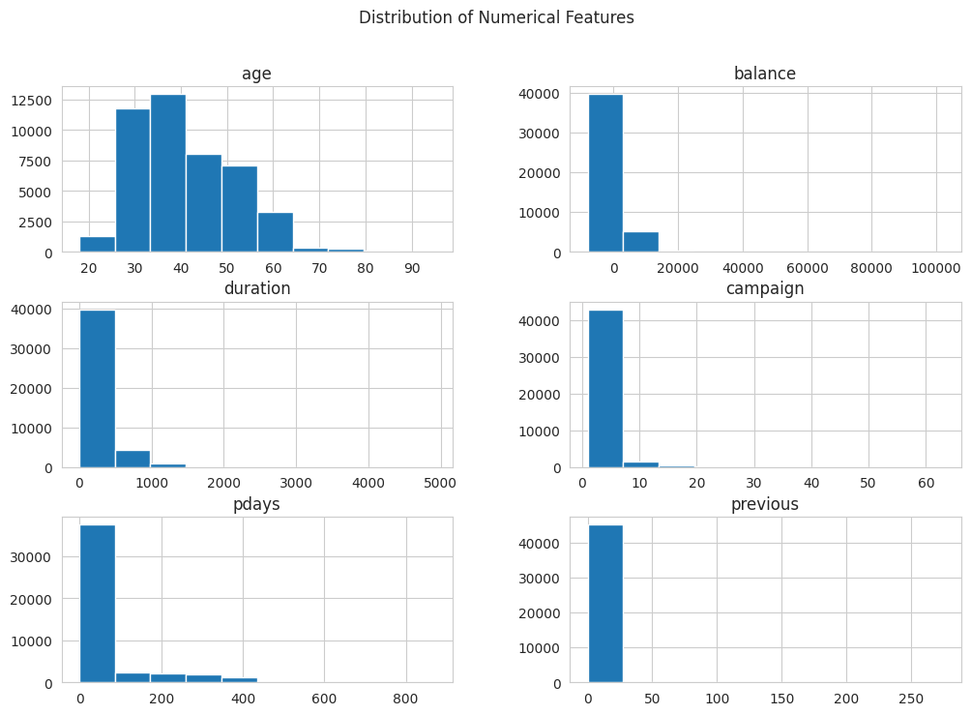
Moreover, the target variable distribution was also tested to determine the possible class imbalance between subscribing and non-subscribing customers. This distribution is significant to understand since an unbalanced set of data may affect the performance of models and bias the predictions to the majority (Verma, 2019).
In order to explore more relationships between variables, a correlation heatmap was produced based on the encoded dataset. The heatmap represents the magnitude and orientation of the relationships among numerical variables and the target one. The analysis assists in determining characteristics that can have a greater predictive power of customer subscription.

4.4.1 Correlation Analysis with Target Variable
To have more insights about the relation between the input features and target variable, correlation analysis was performed on the encoded dataset. The correlation heatmap was created to see the strength and direction of associations between variables and then a list of correlations in a ranked order within the target variable y (term deposit subscription).
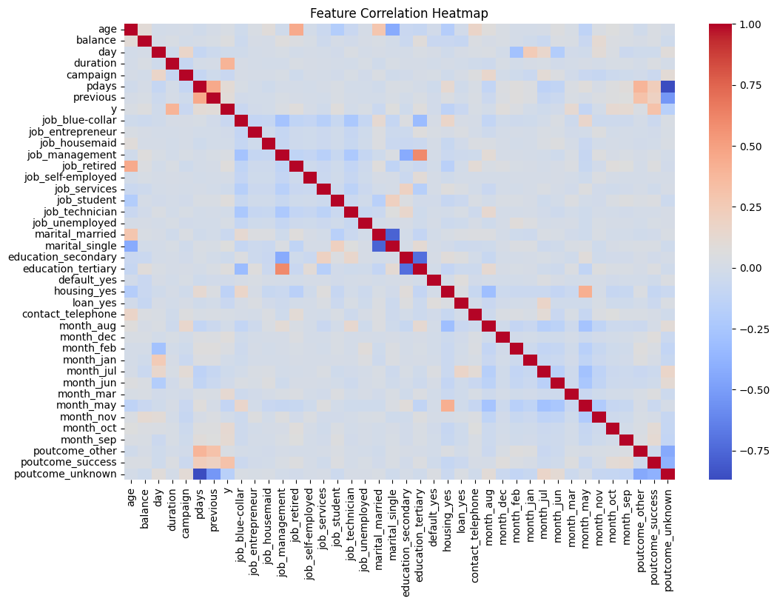
The findings reveal that the duration is positively correlated with the target variable (0.394) and the longer the duration of the call, the more probable is the subscription rate. This is natural, because the longer the customer is involved in conversations, the more is the likelihood that they will positively respond to the marketing initiatives. Equally, the relationship between poutcome success (0.306) is strongly positive meaning that customers who answered campaigns positively in the past have a higher propensity to subscribe again.
A number of the temporal variables also exhibit moderate positive relationships, including month_mar (0.129), month_oct (0.128), and month_sep (0.123), indicating that the timing of campaigns is one of the factors that affect customer response behaviour. Also there are other variables like pdays (0.103) and previous (0.093) which suggests that the history of prior contact has a positive effect on subscription likelihood.
Conversely, there are others that are associated with the target variable negatively. As an example, poutcome -0.167 and housing yes (-0.139) have almost stronger negative relationships, which means that customers who have unknown previous outcomes or housing loans are less likely to subscribe. Likewise, campaign (-0.073) suggests that the more the number of contacts, the lower the likelihood of successful subscription, which could be because of customer fatigue.
Generally, the correlation analysis reveals that variables of customer interaction (duration and previous campaign results) play a key role in subscription behaviour than demographic characteristics. These findings can corroborate findings of the feature importance of the Random Forest model, in which duration and prior interaction-related variables also proved to be critical predictors.

4.5 Model Development
At this phase, various machine learning models with supervision will be constructed to solve the customer subscription to a term deposit classification problem. The three models to be used in this research are Logistic Regression, Decision Tree and Random Forest classifiers. The selection of these models is based on the fact that they are various learning models such as linear modelling, tree-based learning and ensemble methods.
A baseline model will be the Logistic Regression so that a reference level of performance can be set at which binary classification is going to be made. Decision Tree will be used to preserve potential nonlinear interactions between input features and the target variable and be interpretable. Random Forest will be used as an ensemble method to enhance predictive accuracy through combining several decision trees and decreasing the overfitting.
The models will be trained with the ready training dataset and produce predictions on the testing dataset. This step is aimed at performing the comparison of the overall performance of various algorithms on the same dataset and at determining which model is the most effective to predict customer subscription behaviour.
Representation learning approaches enable the use of machine learning models to identify intricate patterns in customer data, and can be used to extract meaningful latent features of banking data (Mancisidor et al., 2021).

4.6 Model Evaluation
After the development of the models, the performance of every machine learning model will be measured with the help of various classification metrics. These are accuracy, precision, recall and F1-score that give a more holistic view of model performance. The measure of accuracy will be general correctness of the predictions, whereas precision and recall will be used to measure the effectiveness of the model in detecting positive subscription cases. Precision and recall will be balanced by using F1-score.
Besides the numerical measures, the confusion matrices will also be created to give a more detailed account of the prediction results, i.e., true positives, true negatives, false positives, and false negatives. This will assist in the realization of the strengths and weakness of each model.
Besides, a comparative analysis will be done to compare the performance of all models to each other. The results will be presented in the form of visualisations like model comparison plots. The analysis of feature importance, especially that of the Random Forest model, will also be provided to determine the most important variables in the prediction of customer subscription.
Results of this evaluation phase will be utilized in the next section to discuss the findings and identify which model is better to use in the given problem.

5. Results
This part includes a critical analysis of the performance of the three applied machine learning models; Logistic Regression, Decision Tree, and Random Forest. The models were trained with the filtered data set and their results were measured with the traditional classification tools, such as accuracy, precision, recall, and F1-score. These metrics give a holistic perspective of how the model performs especially when there is a class imbalance, which has been proven to be a trait of the Bank Marketing dataset (Verma, 2019). Each model has been discussed and then the results given individually then the comparison made to see what model is the most effective in predicting customer subscription behaviour.

5.1 Logistic Regression Results
The Logistic Regression was used as a control trial model to measure the performance of a linear classification model on the data. The model obtained a score of 0.898, which showed that the model was able to classify the test instances at a rate of 89.8 percent. This would indicate good overall performance at first sight. Nevertheless, accuracy is not adequate to measure the classification models with imbalanced data since it may be deceptive in case one group prevails with other classes.
Further analysis of the performance indicators helps to see the key points. The model had a precision rate of 0.628 meaning that when the model forecasts a customer to subscribe to a term deposit, it is accurate approximately 62.8 times. This is an average capability of not making false positive predictions. The value of recall is however much less at 0.323, indicating that the model only correctly identifies 32.3 percentage of real subscription cases. This implies that many of the true positives are being missed.
The F1-score, which is the ratio of precision to recall, is 0.427, which shows that the model is not as effective at capturing positive cases. The low recall value implies that the Logistic Regression is skewed towards the majority (non-subscription) class, which is prevalent due to the imbalanced datasets. Consequently, the model is likely to categorize numerous real subscribers as non-subscribers.
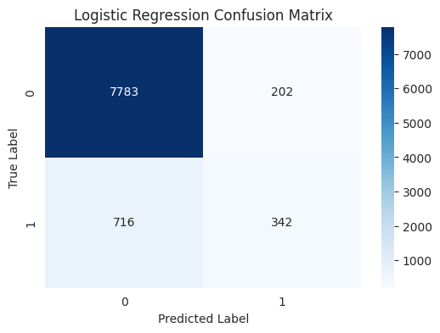
This observation is also backed up by the confusion matrix which indicates that there are a large number of true negatives and a relatively small number of true positives. This imbalance shows the weakness of Logistic Regression in the situation. Although the model is good at determining non-subscribers, it may not be so effective when it comes to determining the potential customers who would probably become subscribers. This is a weakness that minimizes its usefulness in real-life marketing contexts where it is important to have the potential subscribers known.

5.2 Decision Tree Results
The Decision Tree model was adopted to model nonlinear associations amid input features and target variable. Decision Trees, in contrast to Logistic Regression, are able to fit complex interactions between variables and are therefore appropriate when dealing with mixed type features and nonlinear relationships.
The Decision Tree obtained an accuracy of 0.865 which is a little lower than that of Logistic Regression. The model however exhibits alternative behaviour when precision and recall are used to evaluate it. The value of precision of 0.426 shows that the model generates more false positives than Logistic Regression. Differently put, the model is only right under half the time when it predicts a subscription.
Conversely, the recall value of 0.452 is quite much greater than that of Logistic Regression. This means that the Decision Tree is more effective in identifying the real subscribers and it is able to capture the correct positive cases with a hit rate of around 45.2%. This recall improvement indicates that the model is sensitive to the minority class which is a significant advantage in this application.
The F1-score of 0.439 indicates a more equal trade-off between precision and recall than what is available with Logistic Regression. Although the Decision Tree loses some accuracy and precision, it trades off with better recall and is thus more effective at finding out which subscribers there may be.
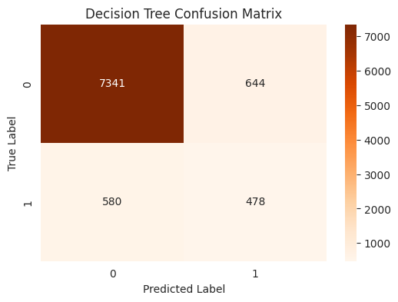
The Decision Tree confusion matrix indicates that the number of true positives is higher than with the Logistic Regression, but false positives are also higher. It means that the model is more aggressive in predicting the positive category, and such a feature can be useful in marketing situations when predicting potential customers is more crucial than false positives.
Decision Trees are however subject to overfitting, especially when they are not regularised. This could be the reason of the reduced general accuracy and precision. Regardless of this drawback, the model offers good understanding of interactions among features and enhances the identification of the minority class.

5.3 Random Forest Results
Random Forest model was applied as an ensemble model of learning to enhance predictive performance and overcome the shortcomings of single decision trees. Random Forest limits the problem of overfitting and improves generalisation by aggregating the predictions of several decision trees.
The model was the most accurate of all models with 0.907 which is better overall classification performance. This implies that the Random Forest model can make the right classification of a higher percentage of observations than both the Logistic Regression and Decision Tree model.
The highest score of the three models based on precision is 0.673, which is the value of the Random Forest. This means that the model can predict a subscription in a way that is right about 67.3 percent of the time. The above enhancement reveals that Random Forest is more faithful in detecting true positive cases and reducing false positives.
The recall value is higher than that of Logistic Regression but lower to a small extent than that of the Decision Tree. It indicates that the Random Forest is, in a way, less aggressive compared to the Decision Tree in detecting all potential subscribers, although it is a good algorithm to detect positive cases. This trade-off is, however, compensated by an important gain in accuracy.
The F1-score of 0.496 is the greatest among all the models and this implies that the model is the most balanced in terms of precision and recall. This illustrates that Random Forest attains better trade-off between the right identification of subscribers and the wrong identification of subscribers.
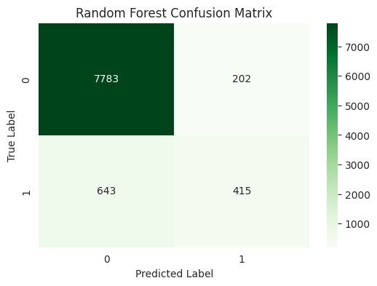
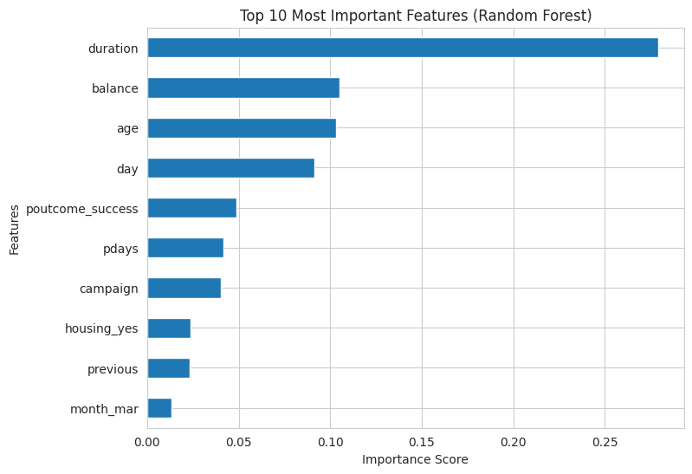
The importance of features analysis further substantiates these findings by indicating that the variables of duration, balance, and prior campaign outcomes have the biggest influence on predictions. This correlates with the correlation analysis above, which supports the significance of interaction-based features in the determination of customer behaviour (Moro et al., 2011).

5.4 Model Comparison and Discussion
An overall comparison of the three models brings out distinct performance and behavioural differences. Although Logistic Regression was relatively accurate, the recall was low, which means that it is highly biased towards the majority class. This renders it not applicable in situations where determining the potential subscribers is of utmost importance.
The Decision Tree model has increased the recall rates and is therefore more useful in identifying positive cases. This was however at the expense of a lower rate of precision and accuracy meaning that it will have more false positives. Although such behaviour is tolerable in some situations, it decreases the overall credibility of the model.
Random Forest was found to be more accurate, precise, and F1-score than both models, which proves that this model could be able to balance the predictive performance. Even though its recall is a little lower than that of the Decision Tree, it offers a superior overall trade-off between true positives and false positives reduction.
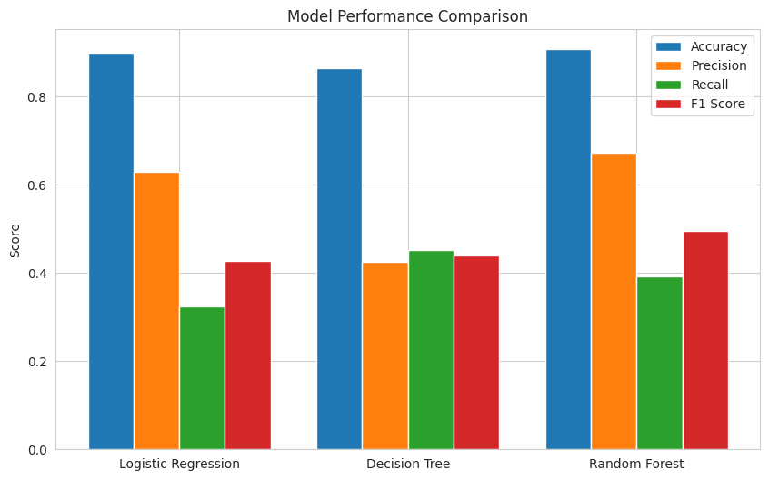The results of the comparison demonstrate clearly that the most appropriate model that should be used in this classification problem is the Random Forest. Its ensemble character enables it to be able to capture intricate relationships in the data without compromising its strength and generalisation. Also, the model can shed some valuable light on the importance of features that can be applied in marketing strategies.
On the whole, the findings indicate that simpler models like the Logistic Regression can be used as an effective baseline but more complicated models like the Random Forest can be used to achieve better results on complex and imbalanced data. These results indicate that ensemble methods are especially useful in the case of financial marketing where predictive accuracy and reliability are critical.

6. Discussion
This section gives a comprehensive interpretation of the study findings relative to the research question, literature and methodology. The main aim of this study was to evaluate the effectiveness of supervised machine learning models: Logistic Regression, Decision Tree, and Random Forest used in predicting customer subscription to bank term deposits using the UCI Bank Marketing dataset. Accuracy, precision, recall and F1-score were used to measure model performance.
The results show that the three models could complete the classification task, but they differed in terms of their performance based on the measures of evaluation. The accuracy of the Logistic Regression was rather high, and it indicates a good overall performance. It did not, though, do well on the recall and the F1-score, i.e. it did not correctly identify a large percentage of the actual subscribers. This is a typical problem of skewed datasets where the truth can be misleading (Verma, 2019). Thus, despite the fact that the model Logistic Regression is a helpful baseline model, it is not adequate to answer the research question.
The Decision Tree model had another performance profile. Although its overall accuracy was less than Logistic Regression, it had a better recall and is more effective in determining the true subscribers. This is especially useful in marketing applications, where determining who might be a customer is often more significant than reducing false positives. But this was at the expense of reduced accuracy meaning that there is increased false positive prediction. This trade-off indicates the overfitting and aggressive classification bias of the model that makes it less reliable in the real world.
Comparatively, the Random Forest model was the most balanced in terms of all measures. It had the highest accuracy, precision and F1-score with a relatively high recall. Though its recall was a bit lower than the Decision Tree, it gave a more optimal balance between the detection of true subscribers, and the reduction of false predictions. This directly responds to the research question, with Random Forest showing the best predictive performance of the models. It is especially appropriate to this classification issue because of its ensemble character, enabling it to pick up intricate trends in the data and minimizing overfitting.
These results are in line with those found in the literature examined in this paper. The fact that the model can deal with nonlinear relationships and imbalanced samples has often been found in the literature as a high-performing model in bank marketing prediction tasks, particularly in cases of imbalanced datasets (Chian et al., 2024; Keerthana et al., 2024). The application of ensemble techniques and CRISP-DM methodologies in studies also revealed its efficiency. Moreover, class imbalance studies have also revealed that ensemble techniques can be further enhanced by incorporation of strategies like SMOTE (Verma, 2019). Recent studies also confirm these findings and emphasize the effectiveness of machine learning models when it comes to enhancing direct marketing prediction and decision-making in the banking domain (Zaki et al., 2024).
Interaction-based features determined in this paper, especially the duration of the call and prior campaign results also correspond to the existing literature (Moro et al., 2011). These variables were observed to significantly impact the customer subscription behaviour in the correlation analysis and feature importance outputs. Such consistency enhances the validity of the results and proves the usefulness of the factors of customer engagement in predictive modelling.
This research employed a methodology that helped to make the results reliable. Preprocessing of the data, such as the treatment of unknown values, encoding of the categorical variables, and normalization of the numerical variables, made the data conducive to machine learning (Fitriani and Febrianto, 2021). Stratified train-test splitting retained the distribution of the classes, which are crucial in imbalanced datasets. The assessment was more comprehensive due to the use of various metrics of evaluation of models.
The study has a number of limitations though. It is founded on a single dataset of a Portuguese bank, which might constrain the externalisability of the results. Also, more sophisticated methods like hyperparameter optimization, cross-validation and class imbalance mitigation algorithms like SMOTE were not implemented to the fullest extent (Verma, 2019). These limitations can be resolved in future research through the use of more advanced methods and testing models on a variety of data sets. The cost-sensitive analysis would be a possibility as well to represent a more practical situation of decision-making (Kok-Chin and Keng-Hoong, 2016).
To sum up, this research paper has managed to answer the research question by showing that machine learning models could be effectively used to predict customer subscription behaviour. Random Forest was the most reliable and balanced among the models considered, so it is the most appropriate to use in this classification task. These results demonstrate that model selection, evaluation metrics, and data characteristics are vital to creating effective predictive models that can be used in financial marketing.

7. Conclusion
This paper has investigated the performance of the supervised machine learning models to predict customer subscription to bank term deposits, using the UCI dataset. Accuracy, precision, recall, and F1-score were used as the criteria to compare the Logistic Regression, Decision Tree, and Random Forest. Logistic Regression was very accurate and the lowest in recall, which meant it was not able to predict real subscribers. The Decision Tree was better at recall but had more false positives. Random Forest performed the best overall, with the combination of accuracy, precision and recall, thus it is the most reliable model. The results are consistent with the literature and show the significance of interaction-based attributes like duration of calls. The study is still effective, but the use of only one dataset and the absence of sophisticated optimization methods limit the study. Random Forest is the best model to use in this prediction.

References
Abbas, S., 2015. Deposit subscribe prediction using data mining techniques based real marketing dataset. arXiv preprint arXiv:1503.04344.
Chian, L.X., Khaw, K.W., Chew, X., Alnoor, A. and Ng, W.C., 2024. Bank direct marketing campaign success prediction. Applied Mathematics and Computational Intelligence (AMCI), 13(3), pp.95-114.
Elsalamony, H.A., 2014. Bank direct marketing analysis of data mining techniques. International Journal of Computer Applications, 85(7).
Fitriani, M.A. and Febrianto, D.C., 2021. Data mining for potential customer segmentation in the marketing bank dataset. JUITA: Jurnal Informatika, pp.25-32.
Gerling, C. and Lessmann, S., 2024. Leveraging AI and NLP for bank marketing: A systematic review and gap analysis. arXiv preprint arXiv:2411.14463.
Kok-Chin, K. and Keng-Hoong, N., 2016. Evaluation of cost sensitive learning for imbalanced bank direct marketing data. Indian Journal of Science and Technology, 9, p.42.
Mancisidor, R.A., Kampffmeyer, M., Aas, K. and Jenssen, R., 2021. Learning latent representations of bank customers with the variational autoencoder. Expert Systems with Applications, 164, p.114020.
Moro, S., Laureano, R. and Cortez, P., 2011, October. Using data mining for bank direct marketing: An application of the crisp-dm methodology. In Proceedings of the European Simulation and Modelling Conference-ESM (Vol. 2011).
Tanvir, M.F., Hossain, M.M. and Jishan, M.A., 2024, December. Bayesian Regression for Predicting Subscription to Bank Term Deposits in Direct Marketing Campaigns. In 2024 International Conference on Decision Aid Sciences and Applications (DASA) (pp. 1-5). IEEE.
Verma, A., 2019. Evaluation of classification algorithms with solutions to class imbalance problem on bank marketing dataset using WEKA. International Research Journal of Engineering and Technology, 5(13), pp.54-60.
Zaki, A.M., Khodadadi, N., Hong Lim, W. and Towfek, S.K., 2024. Predictive Analytics and Machine Learning in Direct Marketing for Anticipating Bank Term Deposit Subscriptions. American Journal of Business & Operations Research, 11(1).

